The schematic below was provided by our software engineer. We had the software engineer research what a web crawler system is, how it works, and what an efficient web crawler system looked like.

A web crawler system is a “bot that searches and indexes content on the Internet.” (<https://blog.hubspot.com/marketing/web-crawler>). In layman’s terms, a web crawler system is what causes web pages to show content that you have: looked up, previously purchased, and/or have added to an online cart for future purchases. Web crawler systems make it easier for corporations such as Nike, Google, Instagram, and Facebook show the consumer items and experiences that they enjoy.

To break down the schematic:

1. The consumer or user will log into a web page
2. Once logged into the web page, the user will search a variety of clothing or destinations
3. The information gathers from the searches is then ranked using an algorithm that calculates how important each search was to the user
   1. The requirements are **time on search page, number of clicks regarding the search, and time on the desired web page**
4. After this information is gathered, it is then stored in a data warehouse or index that will continuously send and receive the data gathered from the user’s use of the page
5. 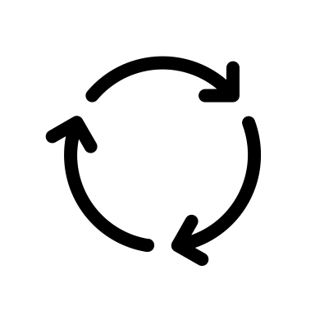The web crawler system then “crawls” amongst the page and takes note of the information being gathered which is then also added to the index.

Web Crawler System

Web Page

Data Warehouse

User

Algorithms

Results

User Queries

Fetch Data

Send Data